Ariza Water Detector Alarm

FEATURES:
- detect conductive liquid, such as water leakage, water level, standing water.
- Turn the power switch to ON to start up and OFF to shut down.
- When the probe contact contacts the conductive liquid, the host will send an 130db alarm
- short press the SET key to tick tick tick, corresponding to the alarm sound 10 seconds, 20 seconds, 30 seconds.

DAIS:
Device:
{
"_id": "10ca2000",
"deviceTypeId": "ezlopi",
"parentDeviceId": "",
"category": "security_sensor",
"subcategory": "leak",
"gatewayId": "457a5069",
"batteryPowered": false,
"name": "ArizaWater Alarm",
"type": "sensor",
"reachable": true,
"persistent": false,
"serviceNotification": false,
"armed": false,
"roomId": "",
"security": "no",
"ready": true,
"status": "idle",
"parentRoom": true,
"protectConfig": "default"
}

Items:
{
"_id": "20ca2000",
"deviceId": "10ca2000",
"hasGetter": true,
"hasSetter": false,
"name": "water_leak_alarm",
"show": true,
"valueType": "token",
"enum": [
"no_water_leak",
"water_leak_detected",
"unknown"
],
"valueFormatted": "no_water_leak",
"value": "no_water_leak",
"status": "idle"
},
{
"_id": "20ca2001",
"deviceId": "10ca2000",
"hasGetter": true,
"hasSetter": false,
"name": "battery",
"show": true,
"valueType": "int",
"scale": "percent",
"value": 65,
"valueFormatted": "65",
"status": "idle"
}
]

PICTURES:
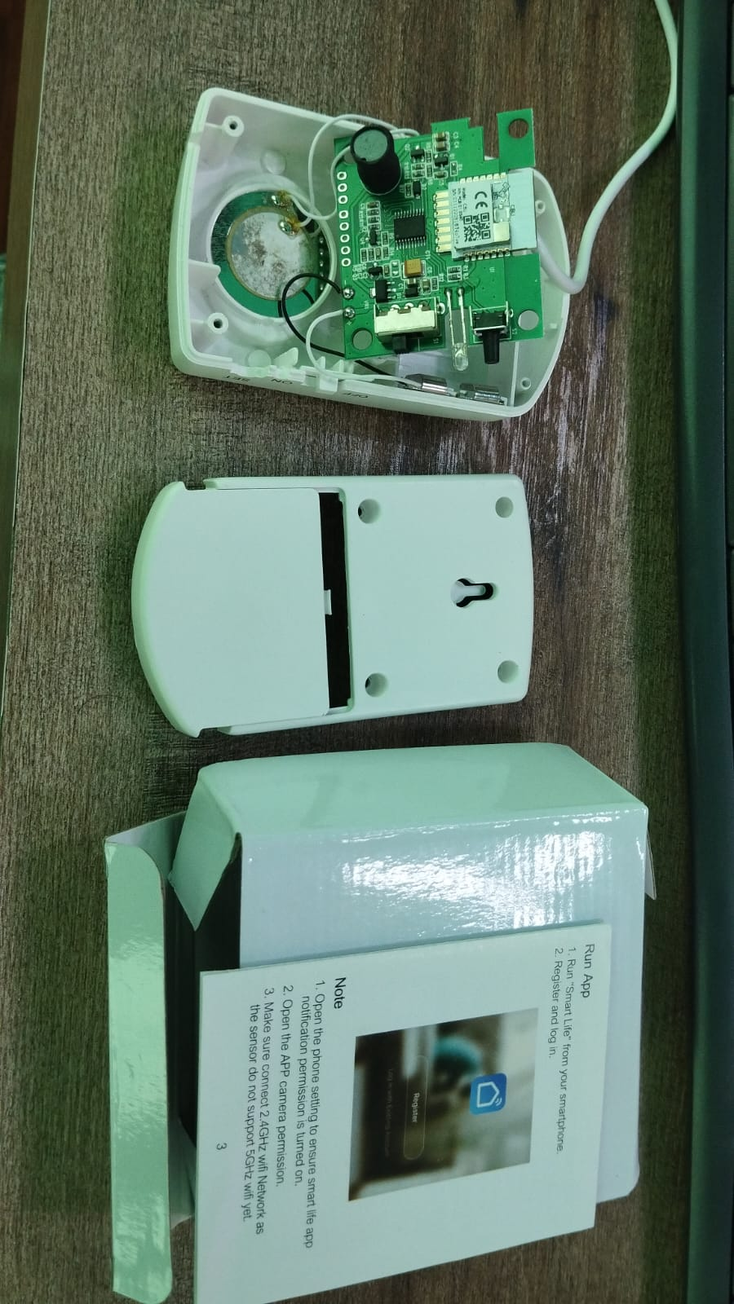
Device Inside View
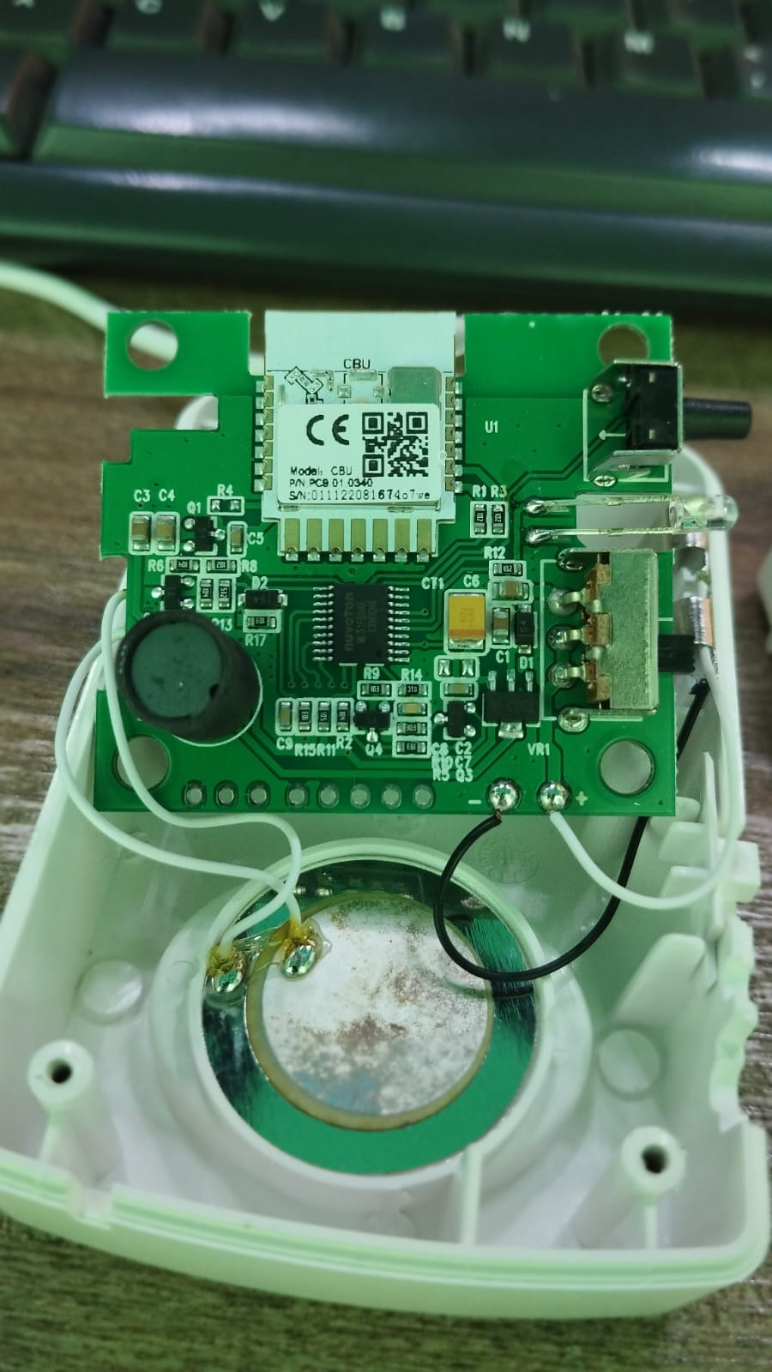
Device PCB

